Tenda Nova MW6——How to remove a nova unit from a network?
You need to remove a nova unit from its mesh network system in the following cases:
- You want to use the nova units in a suite separately.
- You buy 2 suites, each of which contains 2 or 3 nova units. You want to use them together to establish a bigger mesh network system.
- You have two nova units, one in your office and the other at home. But you want to use them together.
- You want to remove one nova unit from an established network system and use it alone.

If you want to remove one or more nova units from your mesh network system, use either of the following methods:
Method 1: Remove it using the Reset button.
Procedure: Power on the nova unit, hold down the “Reset” button for 20 seconds until its LED turns solid white. In this case, the factory settings of the nova unit are restored.
Method 2: Remove it using the Tenda Wi-Fi app。
Step 1: Log in to the app and tap the nova unit on the home page.
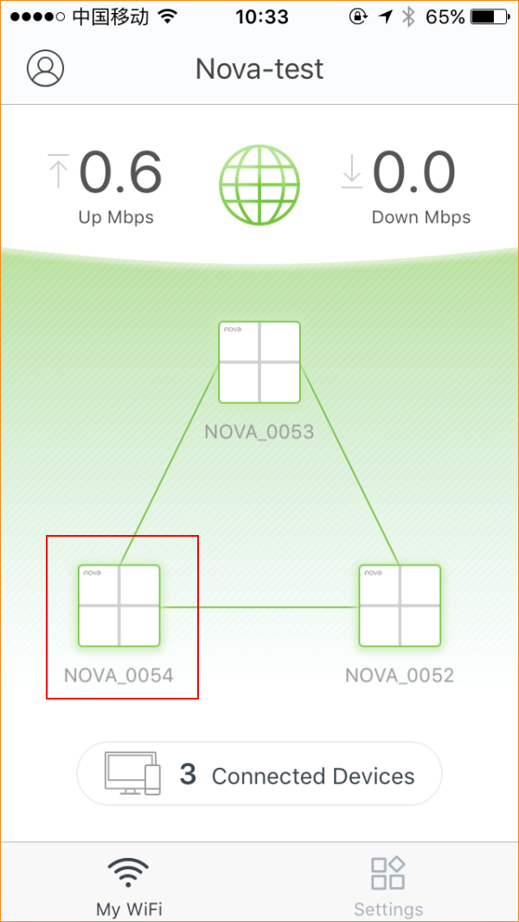
Step 2: Tap the icon “…” in the upper right corner and tap “Delete”.
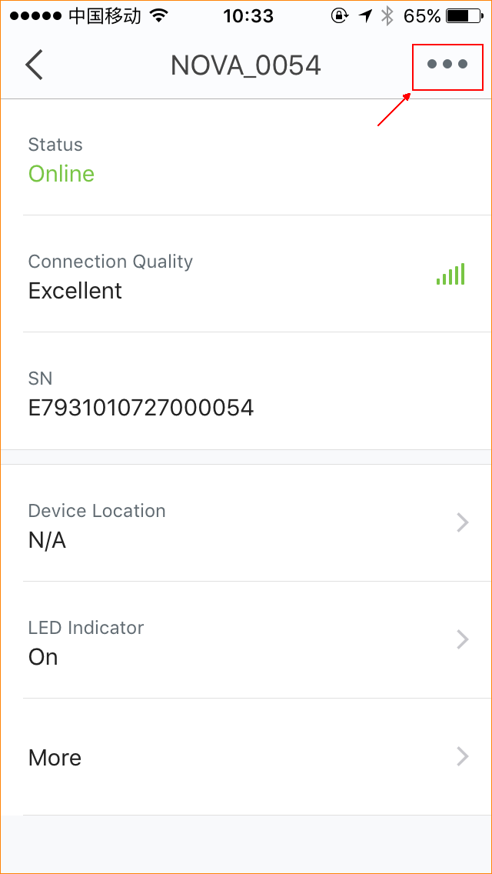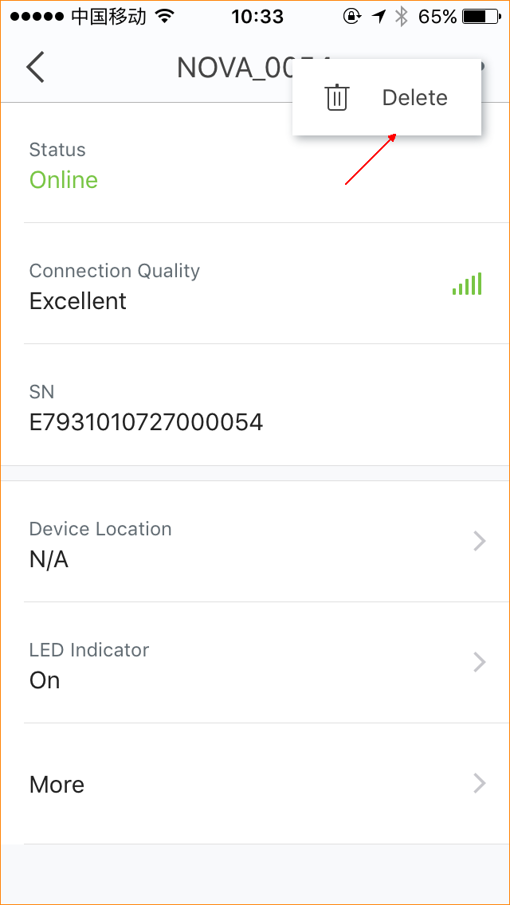
The removed nova unit disappears from the home page.
